# CIRCUIT DIAGRAM:

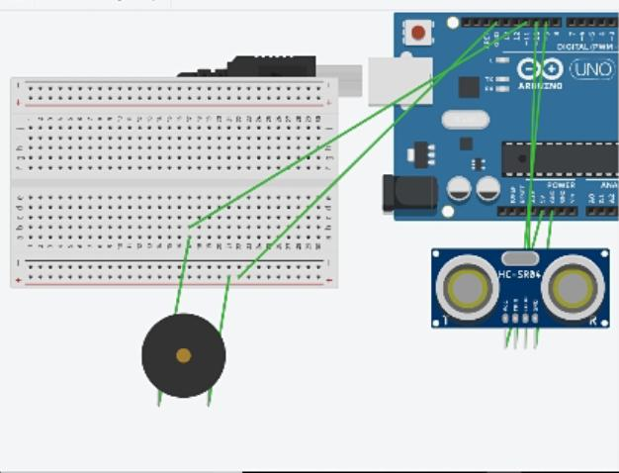

# THEORY:

# In this experiment we are using an ultrasonic sensor to sense a distance and change of distance on the top of a temple gate. Whenever distance changes buzzer buzzes due to change in distance.

# LEARNING AND OBSERVATION

1. First thing I observed is that our ultrasonic sensor is totally dependent on the code we write.
2. Ground pin is always attached to the negative part of buzzer.and positive is connected to input pins of ardino.
3. We have 13 output pins and we are free to use anyone.
4. I observe that ultrasonic sensor is very sensitive device which can measure the distance as per written in the code.
5. I also learnt how the connection are done between ultra sensor and ardino.

# PROBLEMS AND TROUBLESHOOTING

1. First a biggest problem I faced is connection of wiring `in breadboard. One should be careful while adjusting pins in breadboard. Use only those pins which you have written in code for output.
2. During this experiment I also faced problem in writing its code. Because its code is highly logical and it needs some key words which have to be remember.

# PRECAUTION

1. Be careful while doing connections in breadboard.
2. Write code carefully so that it syntax do not contain error.
3. Your code must be written in a manner as per requirement of the output.

# LEARNING OUTCOME

After doing this experiment now I am able to check distance of any object by using ultra sonic sensor and I also learnt its code and how to connect ultrasonic sensor with a Arduino. Now, I am able to perform some more simple experiment using ultrasonic sensor by just doing little variation in the program.

Use of ultra sonic sensor is very helpful in many daily routine activities such as alarming whenever a persons enters in the room or exits the room etc.